**ORACLE RAC**

**RAC** stands for **Real Application Clusters**. It’s a high availability solution for **Oracle DB**. Here two or more nodes (instances) are clustered as a single DB by using shared disks. So there’s no single point of failure from the DB side. A cluster comprises different interconnected computers or servers that show up as in case they are one server to conclusion clients and applications. Oracle RAC empowers you to cluster Oracle databases.

Oracle RAC employments Oracle Clusterware for the foundation to tie numerous servers so they work as a single system. Oracle Clusterware may be a convenient cluster administration arrangement that coordinates with Oracle Database. Oracle Clusterware is additionally a required component for utilizing Oracle RAC. In expansion, Oracle Clusterware empowers both single-instance Oracle databases and Oracle RAC databases to utilize the Oracle high-availability foundation. Oracle Clusterware empowers you to make a clustered pool of capacity to be utilized by any combination of single-instance and Oracle RAC databases.

**RAC architecture**

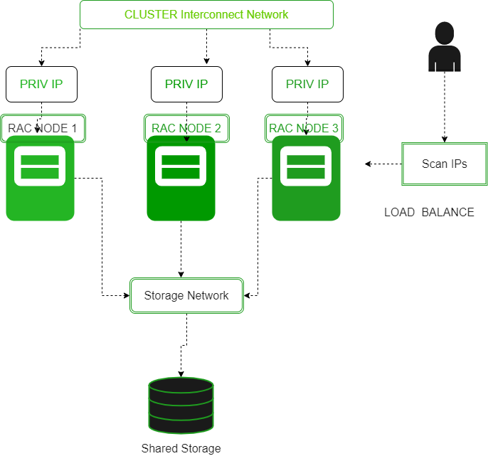

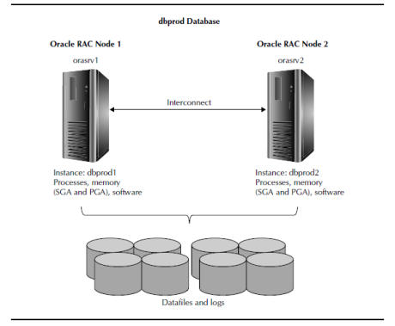

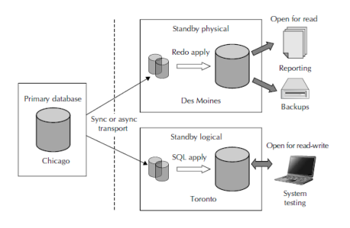

**Applications of RAC**

* Autonomous Health Framework
* Oracle Application Continuity
* Oracle Database Quality of Service Management

**Features of RAC**

* **High Availability**  
  Real Application Clusters gives clients the most noteworthy database accessibility by expelling person database servers as a single point of failure. In a clustered server environment, the database itself is shared over a pool of servers, which suggests that on the off chance that any server within the server pool falls flat, the database proceeds to run on surviving servers. Oracle RAC not only empowers clients to proceed to prepare database workloads within the occasion of a server disappointment, it too makes a difference to assist decrease costs of downtime by lessening the sum of time databases are taken offline for arranged upkeep operations.
* **Database as a Service**  
  Real Application Clusters gives all the computer program components required to effectively send Oracle Databases on a pool of servers and take full advantage of the execution, versatility, and accessibility that clustering gives. Oracle RAC utilizes Oracle Grid Framework as the establishment for Prophet RAC database frameworks. Oracle Network Foundation incorporates Oracle Clusterware and Oracle Programmed Capacity Administration (ASM) that empowers the effective sharing of server and capacity assets in a profoundly accessible and adaptable database cloud environment.

**Advantages OF RAC**

* **Certain patches can be applied in its rolling mode.**  
  In rolling fixing, each hub is closed down in Oracle RAC, at that point the fix is connected. Once that happens, the hub is brought back up once more. By going independently to each hub, a total shutdown is maintained a strategic distance from, which is why the uptime for this alternative is reliably at or close 100%. In spite of the fact that a few patches cannot be connected in this mode, you still have the least downtime fixing highlights that will still assist you to stay beneficial.
* **It is load balanced for a better performance**  
  With Oracle RAC, the administrations facilitate their sessions by enrolling in their workload. They can too enlist the sum of work being taken care of. With this data, clients can be diverted to the least-loaded hub that’s running an occasion for their particular administrations. Two sorts of stack adjusting are included: client-side and server-side. This makes it conceivable to keep working at the speeds you require without the same dangers of data misfortune.
* **Unless the connections are not RAC aware, there is no need for a reconnection.**  
  Since Oracle RAC could be a node-based framework, impromptu disappointments make a negligible effect on the user when compared to comparable administrations. To preserve accessibility, clients who are associated with a fizzled occasion are promptly built up to a new connection with the surviving occasions inside the database. A reconnection isn’t vital beneath most circumstances since you’re basically moving your hub nearness. As long as the essential location remains intaglio, this advantage regularly remains.
* **DML processes are able to roll back.**  
  There are times when you’re working within the SQL Also environment when your information control dialect articulations don’t go as arranged. Rather than having your articulation gotten to be quickly changeless, this framework permits you to see the impact of a DML explanation in Engineer. It does not end up lasting until you total an exchange that incorporates it.

**Disadvantage of RAC**

* **It requires a specific network configuration to work properly**  
  With Oracle RAC, you must have your Check IPs, your VIPs, and your open IP addresses all on the same open arrange for the database to function appropriately. The private IPs must be on a diverse arrange than the open organize. You must have your private and open IPs be pingable sometime recently the establishment starts. In case one link in this chain isn’t input, at that point, you may create an erroneous organize arrangement mistake.
* **You must have Oracle RAC on shared storage**  
  With Oracle RAC, you must have your database records, your OCR area, and your voting disk all on shared capacity. In the event that you are doing not, at that point it’ll not work appropriately. Any issue that you simply have with the shared disk arrangement will inevitably cause the framework to fall flat, which creates an erroneous shared disk setup blunder report.
* **lot of prerequisites that must be completed.**  
  After you design the organize for Oracle RAC and Clusterware, you’ll find that each hub within the cluster has particular prerequisites that must be met. You must have at slightest 2 arrange interface cards, open interface names for each hub, and the same private interface names for all hubs as well. Your arrange connector must back TCP/IP and the private interface must bolster UDP for high-speed organize connectors with a switch that underpins gigabit ethernet at least.